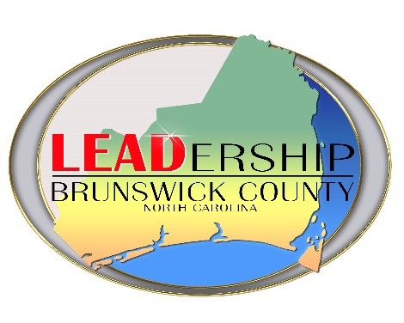
Leadership Brunswick County Accepting Applications

For Immediate Release: July 21, 2023

Contacts: Susan Freeman, Brunswick County Chamber @ 910.754-6644
Dana Fisher, North Brunswick Chamber @ 910.383-0553 or
Karen Sphar, Southport Oak Island Area Chamber @ 910.457-6964.

Brunswick County, NC -- Leadership Brunswick County is a program sponsored by the Southport-Oak Island Area, North Brunswick and Brunswick County Chambers of Commerce to develop corps of informed, committed and qualified individuals capable of providing dynamic leadership for Brunswick County. It is designed to identify highly-motivated, emerging leaders and educate them about the needs of our community, as well as the dynamics of social and economic changes.

Selection for participants in the program requires the applicants to already demonstrate a sincere commitment to serve Brunswick County through community involvement. Applicants should currently hold, be retired from, or have the potential to advance to a management/leadership position. Applicants must reside and/or work in Brunswick County and desire to participate in a nine-month program that promises to challenge and enrich them.

A limited number of leaders/emerging leaders will be selected to participate in Leadership Brunswick County. They will meet one day each month beginning September 2023 through May 2024 with existing leaders from business, government, and education, to explore the needs of Brunswick County and better understand the individuals and services responsible for meeting those needs. Programs will include: the history and culture of Brunswick County, local and state government systems, justice and law enforcement, education, environment, health and human services, and economic development.

Applicants must commit to attend the September 20th orientation retreat, a minimum 6 sessions from the eight sessions between October-April, volunteer a minimum of 10 hours total at a Brunswick County non-profit organizations, attend one regular municipal or county meeting, attend three enrichment activities provided by a Chamber in Brunswick County between September 20th – April 17th and attend the All County Chamber Business Networking After Hours on November 15th to be eligible to graduate from the program.

Applications must be received from all interested persons and reviewed by the Selection Committee. The committee strives to ensure broad demographic participation with an emphasis on representation from the geographic areas and professional categories in the county. Tuition is $400.00 for Chamber members and $450.00 for non-Chamber members and is due with the completed application by 4:00 pm Monday, August 28, 2023. Participants will be notified of selection no later than September 8, 2023.

To receive an application, or for more information, please contact Brunswick County Chamber @ 910.754-6644, North Brunswick Chamber @ 910.383-0553 or Southport Oak Island Area Chamber @ 910.457-6964.

